**CAPSTONE PROJECT - THE BATTLE OF NEIGHBORHOODS (Report)**

**DATA SECTION:**

In order to resolve our business problem we need the data about elementary public school In Chicago. We found our dataset on [Kaggle](https://www.kaggle.com/chicago/chicago-public-schools-data), this dataset is hosted by the city of Chicago. The city has open data platform and they update their information according the amount of data that is brought in Explore the city of Chicago using Kaggle and all of the data sources available through the city of Chicago. This dataset has about 78 columns but we will not need all of them. Let’s remind that we need to find an elementary school with high instruction level, high teachers score and high safety score.

After loading our dataset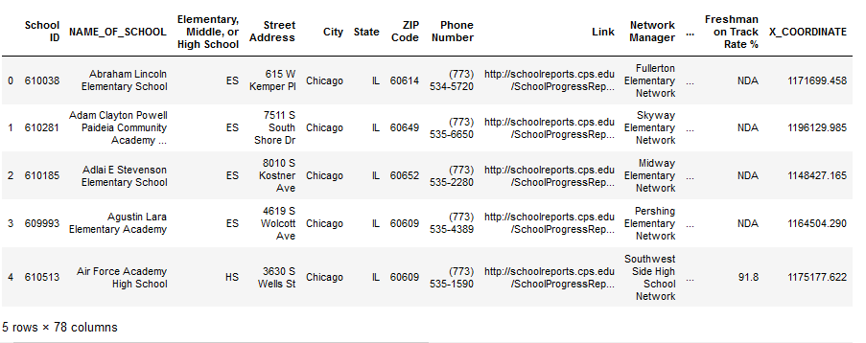 we have seventy-eight (78 )columns and five(5) rows.

Here we can see the average of each columns in our dataset loading

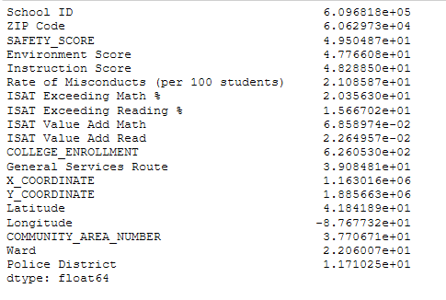

This table show how many things there’s in our dataset like: how many School ID that there’s the average, the equation, the minimum, the maximum , of the 25% ,50%,75% quantity.

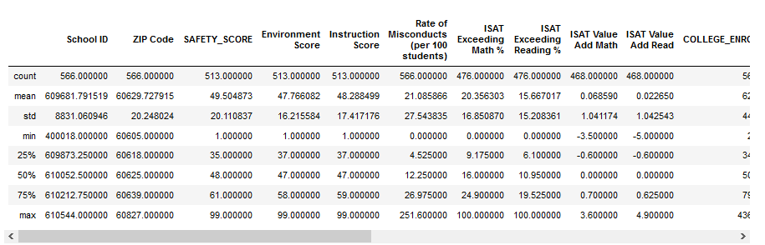

Among the 78 columns those we keep are:

* NAME_OF_SCHOOL
* Elementary, Middle, or High School
* SAFETY_SCORE
* Instruction Score
* Teachers Score
* Latitude
* Longitude
* COMMUNITY_AREA_NAME
* Location
* Street Address
* 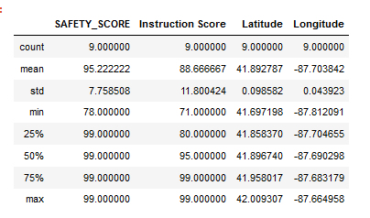So we have our columns and sorted the Elementary Schools having a **SAFETY_SCORE, Instruction Score,Teachers Score**

We have the dataset of our Neighborhoods to make our Clustering

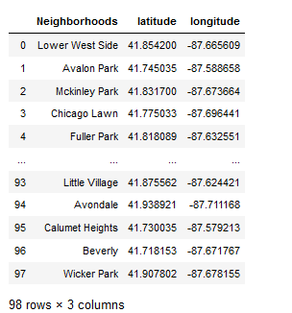

We need another dataset for our School Dance so we went on foursquare to pull data on dance schools in Chicago.

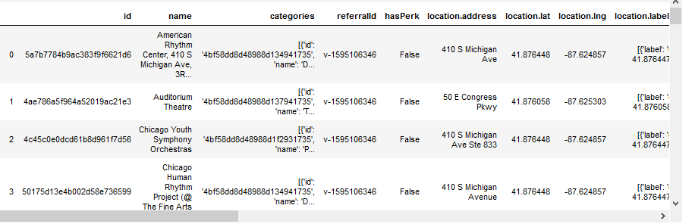

We wanted to see all Elementary School in Chicago with a map

* The blue dots identify the School Elementary at Chicago

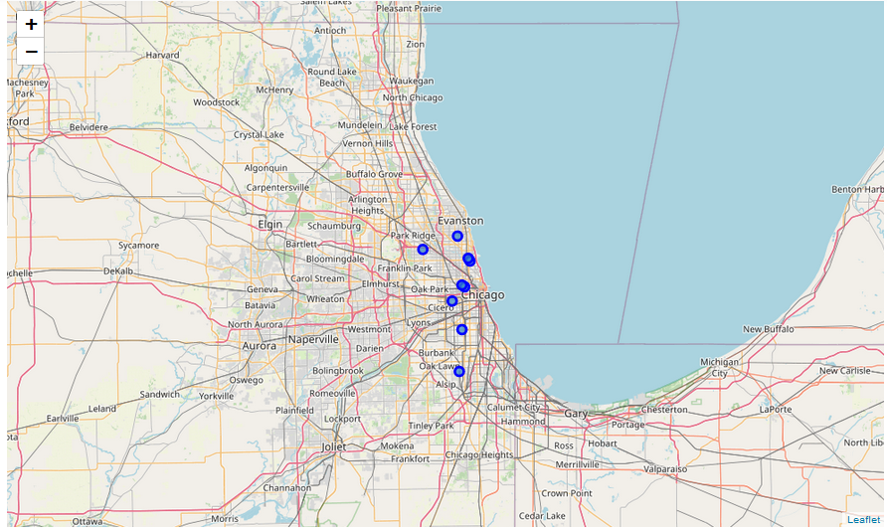

This map this map shows us all elementary schools with a high level of education and reliable security, Teachers Score.

Create map of Chicago using latitude and longitude values.

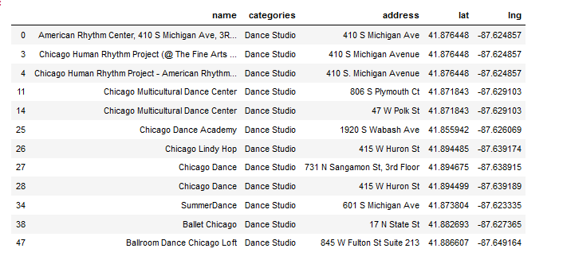For showing the map of all dance school we choose only the dance school that are in Chicago.

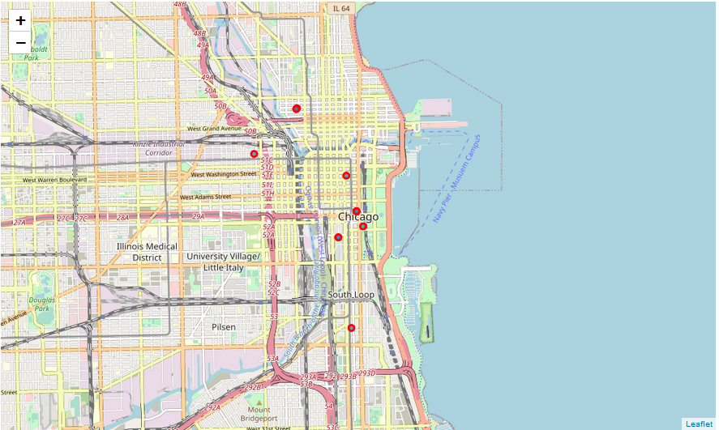This map shows all the dance schools in Chicago.

* The red dots identify the School dance

This map shows us each point of each school either elementary school or dance school so this map shows us very well the elementary students who have a very high education and a very reliable security Teachers Score and those closest to at least one dance school we have identified are the schools of Michell Elementary School and Chopin Elementary School.

* The The red dots identify the School dance
* The The blue dots identify the School Elementary

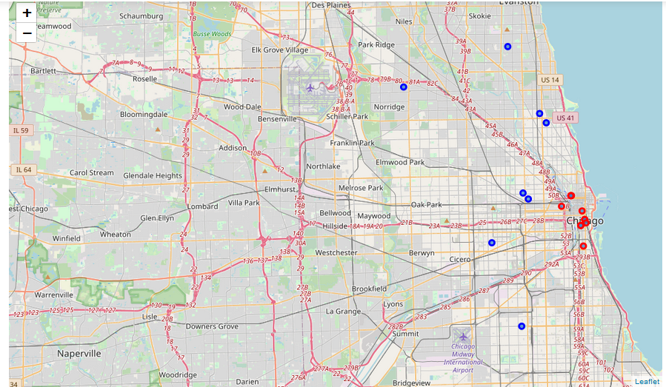

**Conclusion**

There are many elementary schools in Chicago about 566 elementary schools in various area communities, A GPS could guide you well or a map.

Our problem was to find a Dance School close to an Elementary School at Chicago and that the elementary school would be a good school by certain criteria such as:

* **SAFETY_SCORE**
* **Instruction Score**
* **Teachers Score**

Enough security of very competent teachers and a very high level of instruction so that the children would be literally well

After doing our analysis and research through Foursquare, Folium, Clustering and others, there are two Elementary schools with the required criteria that are located near a dance school in Chicago and their names are:

* **Michell Elementary School**
* **Chopin Elementary School**

Parents will be able to manage their time when they put their children in an elementary school with a high education score and find a **Dance School**close enough to that **Elementary School** and its **Elementary School** with high education score is good enough to take care of the students' education. Even if there are parents who will not put their children in a ready-made dance school